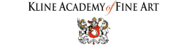
3264 Motor Ave. LA, CA 90034 | 310-927-2436 | klineacademy@att.net
SUPPLY LIST
Introduction to Oil Painting
PLEASE HAVE EVERYTHING READY TO GO ON THE FIRST DAY OF CLASS
Raw Materials and Art Supplies in DTLA has a discounted kit for this class and it is available for curbside pick up, local bike delivery or shipping. Purchase your kit HERE https://rawmaterialsla.com/kits/kline-academy/foundations-in-classical-painting and contact the store at (800) 729-7060 if you have any questions.
You can order your supplies online by clicking BLICK U
Brushes
During the first class for the Compass project you will not need many brushes. After the first class be sure to have a selection of the following:
● Brights #4 through #20 (You don’t need every number, just a selection)
Recommended Brand – Rosemary & Co Artists’ Brushes (Graphaids Inc. on Washington Blvd in Culver City carries the Classical Painting brush set for Kline Academy), Isabey Memory or Raphael Kevrin (Please note that both Isabel and Raphael make many types of brushes so be sure it is “Memory” or “Kevrin” before you purchase)
● 1 ½” to 2” inexpensive large paint brush (See the image below)
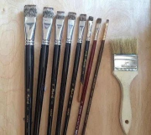
1
3264 Motor Ave. LA, CA 90034 | 310-927-2436 | klineacademy@att.net
Canvas
One 20x20" cotton canvas (The more expensive canvases, like 1.5” box frame, have a nicer surface to paint on). Please see Compass Rose Preparation Image below and try to prepare your canvas before coming to your first class.
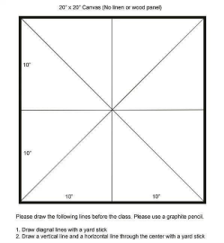
Paints
I will recommend brands that have the nicest color. Please though, DO NOT BUY CHEAP PAINTS OR STUDENT GRADE. I also do not recommend Winsor & Newton because the color of their paints varies greatly from other brands. For instance, Naples yellow is a huge difference. Brands of paint I recommend are: Williamsburg, Old Holland, Vassari, Michael Harding, and RGH Paints.
RGH has a Kline Academy Classical Painting Set that includes all the colors for this class. Order at 518-446-0425. (Mention you are a student at Kline Academy when placing an order and they will give you some samples.)
First few weeks you will need:

2
3264 Motor Ave. LA, CA 90034 | 310-927-2436 | klineacademy@att.net
● Raw umber – Brownish oil paint by Norma or Old Holland brands has a beautiful golden shade. Other brands of raw umber tend to be much cooler.
●Titanium white – If you are on a budget, buy Rembrandt, original formula – large tube. A really nice white is Williamsburg titanium white.
After the 3rd or 4th class, we will begin color. Here are the paints you will need: ● Cadmium red light or French vermillion
● Yellow ochre – color varies with different brands, make sure it is not too dark ● Ivory black
Then add glazing colors:
● Transparent red oxide – Rembrandt is okay
● Transparent Brown Oxide – Rembrandt if okay
● Ultramarine Blue – deep
● Phthalo blue
● Alizarin crimson (do not buy the “permanent” Alizarin)
● Phthalo Green (aka Thalo)
● Indian yellow
Optional colors
● Naples yellow – Mussini only – Also do not buy Naples yellow light or dark, just plain Naples yellow
3
3264 Motor Ave. LA, CA 90034 | 310-927-2436 | klineacademy@att.net
● Chrome Green Opaque (Also called Chromium oxide green)
● Cerulean blue
Other supplies
● Pencil
● Kneaded eraser
● Roll of blue tape
● Spray fix or cheap hair spray (Aquanet Hair spray is actually the best)
● Thin cotton rags – T-shirts works best
● Walnut oil or Refined linseed oil
● A small container for medium
● Palette – light wood palette or disposable palette pad
● Roll of paper towels – Please always bring a roll with you and do not use the one in the bathroom

4

